**Research Report: Library Managment System**

**---**By Taksham Sharma

Jims sector-3

**Introduction**

**Purpose of the Library Management System:**

A Library Management System (LMS) is a software solution designed to manage and automate various library operations. It aims to streamline the process of managing library resources, including books, journals, and digital media, while providing an efficient way to track transactions and manage user accounts.

**Scope of the System:**

The LMS will handle:

* User registration and management
* Cataloguing and classification of books and other resources
* Issuing and returning of books
* Fines and penalties management
* Reporting and analytics for library usage

**System Overview**

**System Architecture:**

The system will be based on a client-server architecture, with a central server managing the database and business logic, and clients accessing the system through a web interface.

**Functional Components:**

* User Management: Handles user registration, authentication, and profile management.
* Book Management: Manages cataloguing, classification, and inventory of books.
* Transaction Management: Tracks borrowing and returning of books.
* Reporting and Analytics: Generates reports on library usage, book circulation, and other metrics.

**System Features**

**User Management:**

* Registration and authentication of users (students, staff, and librarians)
* User profiles with borrowing history
* Role-based access control

**Book Management:**

* Cataloguing and classification of books using standard library classification systems
* Search functionality for books by title, author, ISBN, etc.
* Inventory management with tracking of book availability

**System Requirements**

**Hardware Requirements:**

* CPU i3 7generation,Amd Ryzen series 5000

**Software Requirements:**

* Operating System (Linux/Windows)

**Design and Implementation**

**Design:**

The File will include records for users, books, transactions, and Available books.

**User Interface Design:**

The user interface can be designed for ease of use, with separate interfaces for librarians, staff, and students in future . The design will prioritize usability and accessibility.

**Code**

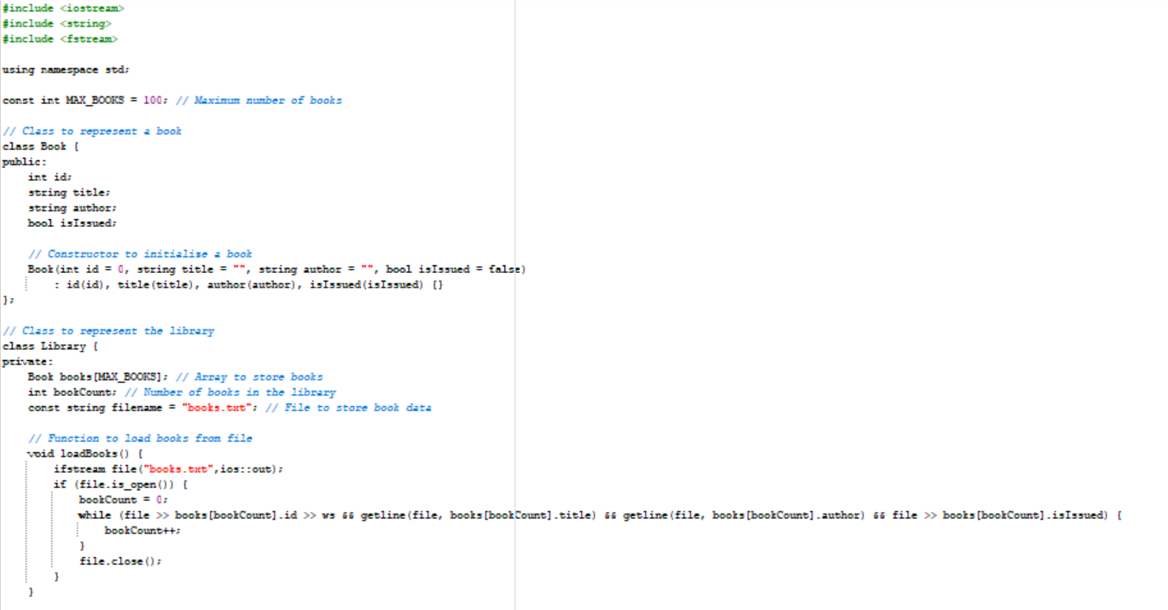

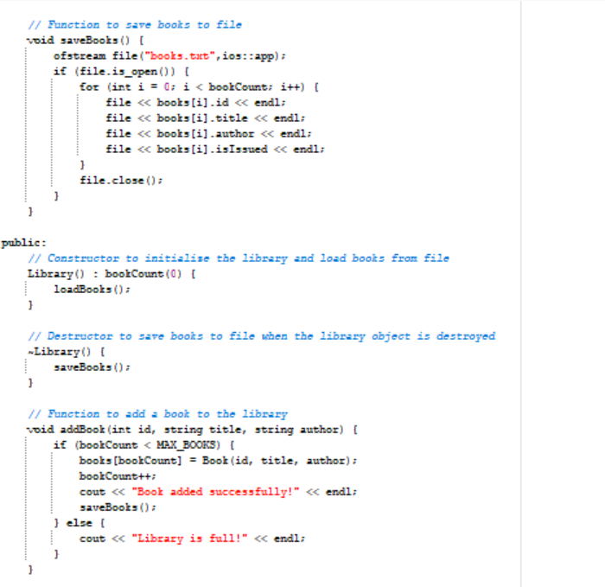

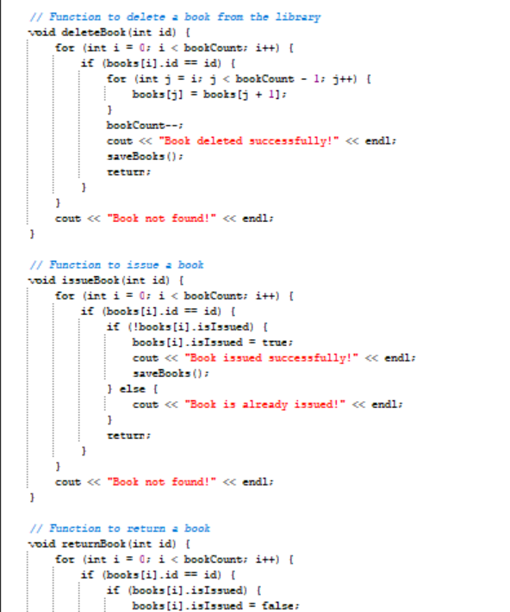

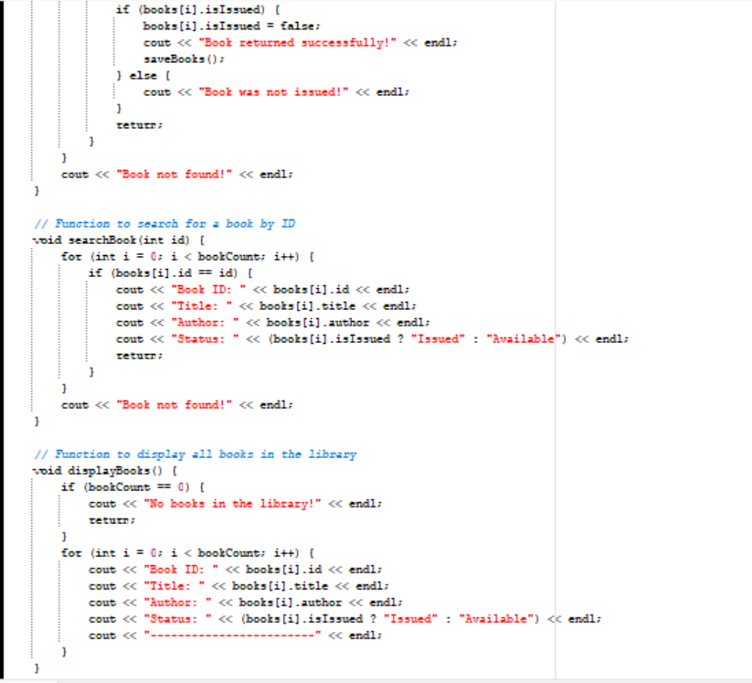

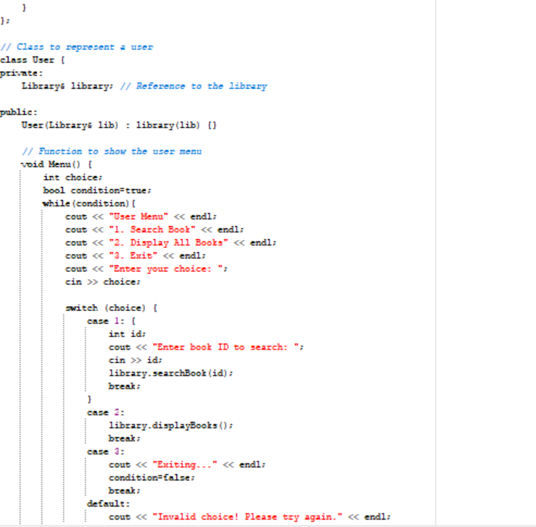

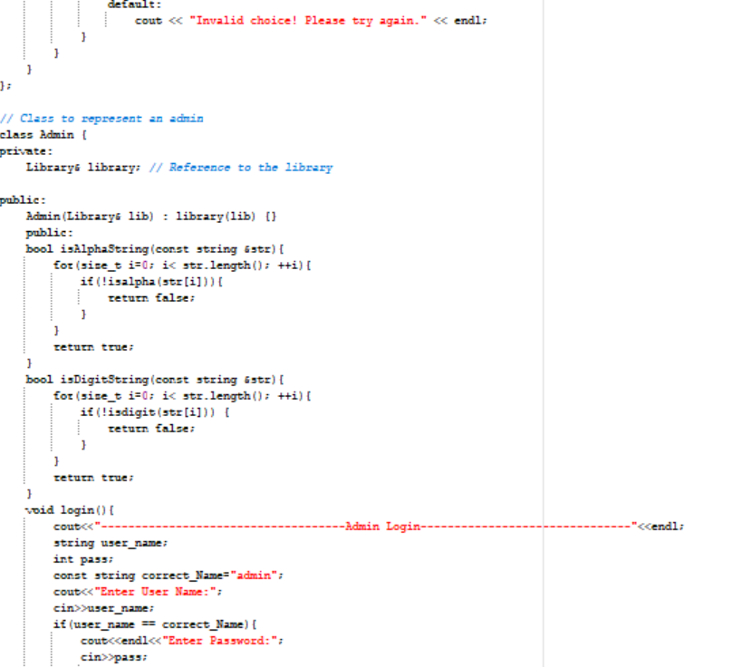

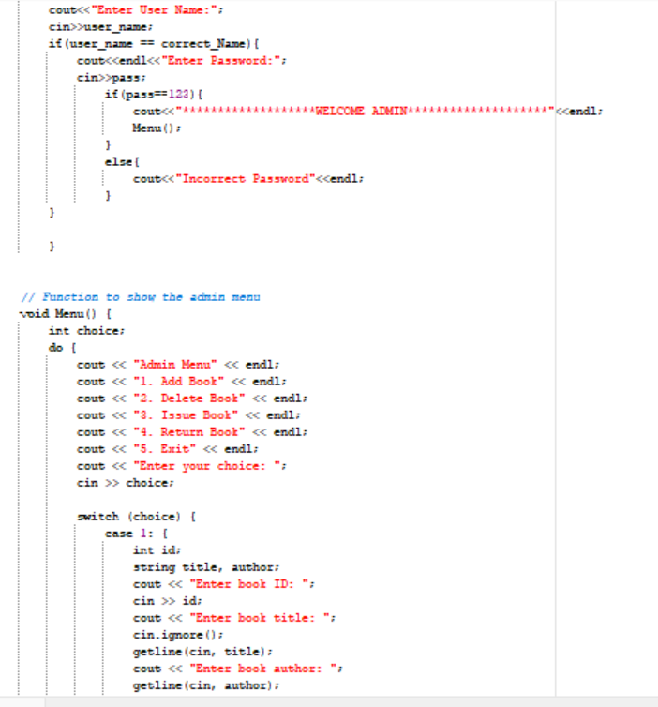

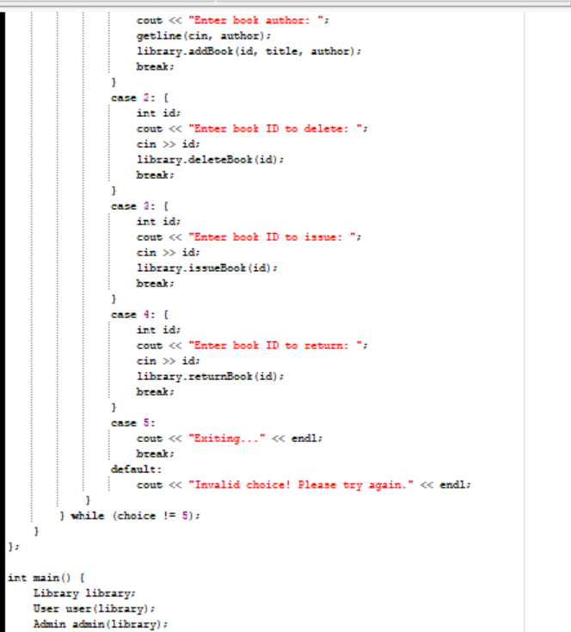

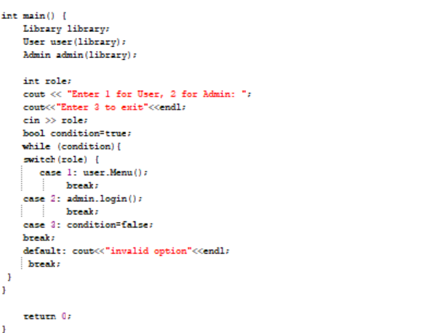

**Testing and Validations**

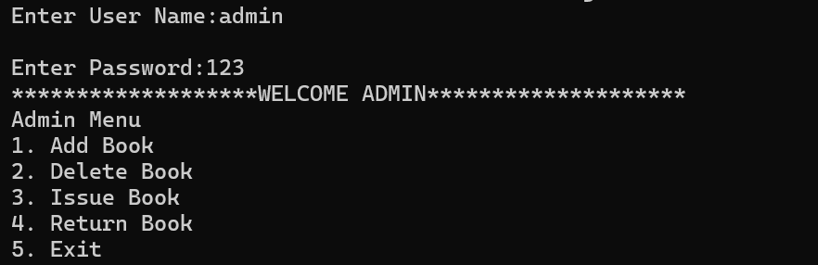

**Fig-1: Admin menu**

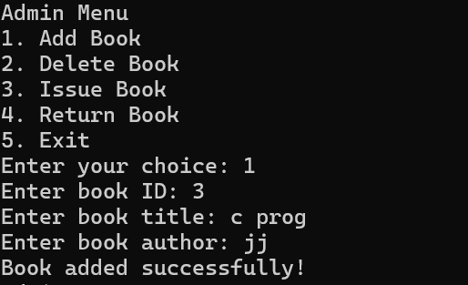

**Fig-1: Add a book**

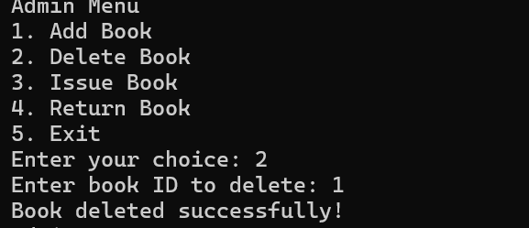

**Fig-3: Delete a book**

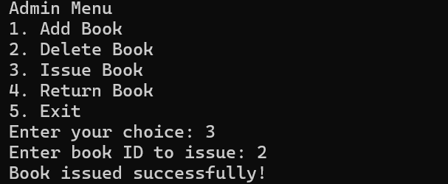

**Fig-4: Issue a book**

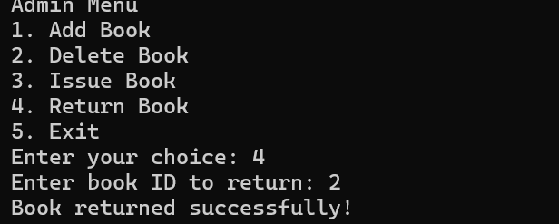

**Fig-5: return a book**

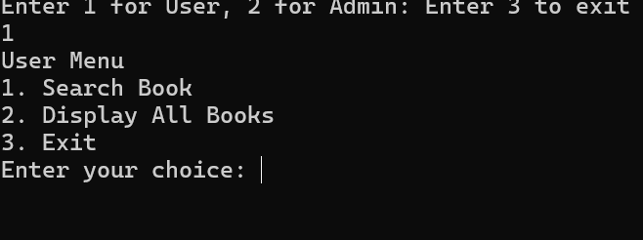

**Fig-6: User menu**

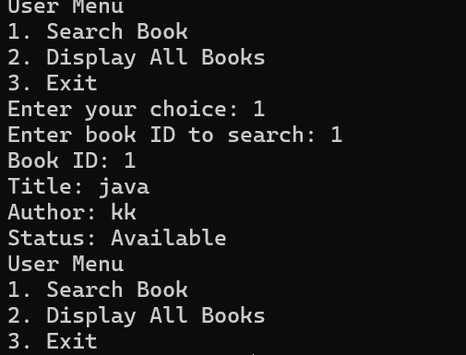

**Fig-7: search a book**

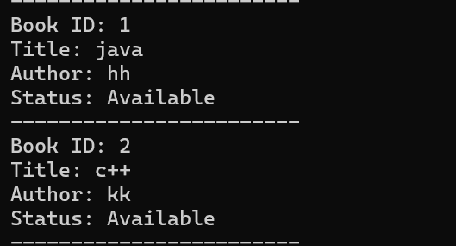

**Fig-8: Display all the books**

**Testing and Deployment**

* Testing Strategies
* Unit testing for individual components
* Integration testing to ensure components work together
* User acceptance testing to validate functionality against requirements
* Deployment Plan
* Initial deployment in a controlled environment
* Gradual rollout to all users
* Monitoring and issue resolution post-deployment

**Maintenance and Support**

* Maintenance Plans
* Regular updates and patches for the software
* Performance monitoring and optimization
* User feedback and feature enhancement

**Future Enhancements**

* Integration with e-books and digital media
* Mobile application for accessing the LMS on the go
* Advanced analytics with machine learning for predictive insights

**Conclusion**

The Library Management System is designed to streamline library operations, enhance user experience, and provide comprehensive reporting and analytics. With robust security measures and a structured deployment and maintenance plan, the system will be a valuable tool for managing modern libraries effectively.